Ideia do Funcionamento

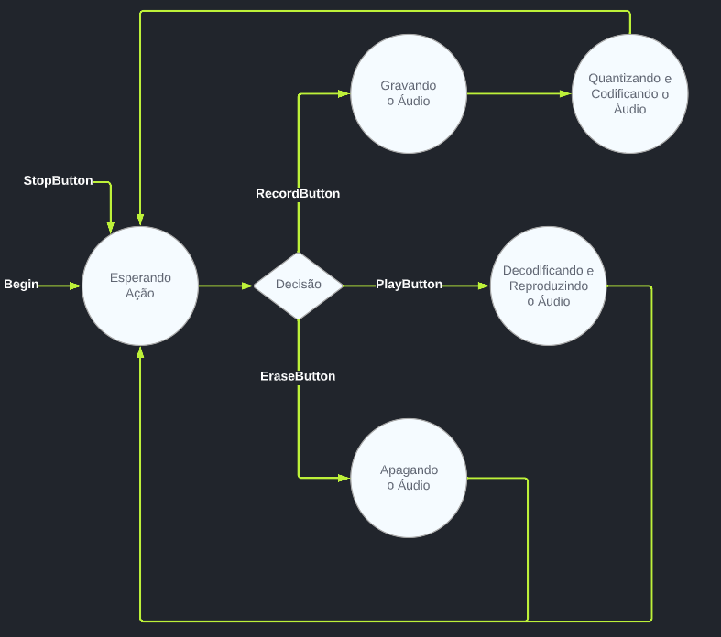

Pinagem dos Elementos

| Elemento | Tipo | Pino |
| --- | --- | --- |
| Record Button | INPUT | 32 |
| Erase Button | INPUT | 35 |
| Play Button | INPUT | 34 |
| Sensor Ruído | INPUT | 25 |
| Alto Falante | OUTPUT | 26 |
| Led Vermelho(Record) | OUTPUT | 18 |
| Led Azul(Play) | OUTPUT | 19 |

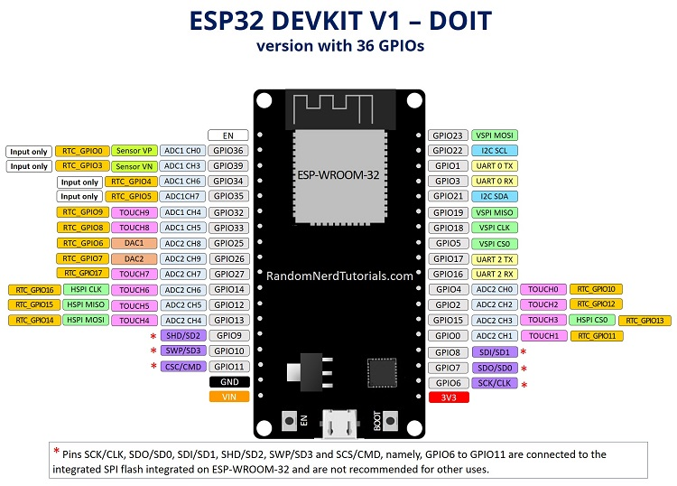  
[ESP32 Pinout Reference](https://randomnerdtutorials.com/esp32-pinout-reference-gpios/)

|  |  |  |  |  |  | Som | Sens |  | Rec | Eras | Play |  |  |  |
| --- | --- | --- | --- | --- | --- | --- | --- | --- | --- | --- | --- | --- | --- | --- |
| Vin | GND | 13 | 12 | 14 | 27 | 26 | 25 | 33 | 32 | 35 | 34 | Vn | Vp | En |
| 3v3 | GND | 15 | 2 | 4 | RX2 | TX2 | 5 | 18 | 19 | 21 | RX0 | Tx0 | 22 | 23 |
|  |  |  |  |  |  |  |  | Led | Led |  |  |  |  |  |

Dados para quantização

NumBits: 6

Frequência Amostragem: 1 kHz

[Tinkercad](https://www.tinkercad.com/things/gViHBwCFvHf-brave-bruticus/editel?sharecode=FFNHbJHSXfwl25KO9FdRgJGFNJ_onBe8YsPDHi4qBDU)

Ideia Config Circuito na Placa

